NEW JERUSALEM EVANGELICAL LUTHERAN CHURCH
27 Lyons Road, Fleetwood, Pa.
Rockland Township, Berks County

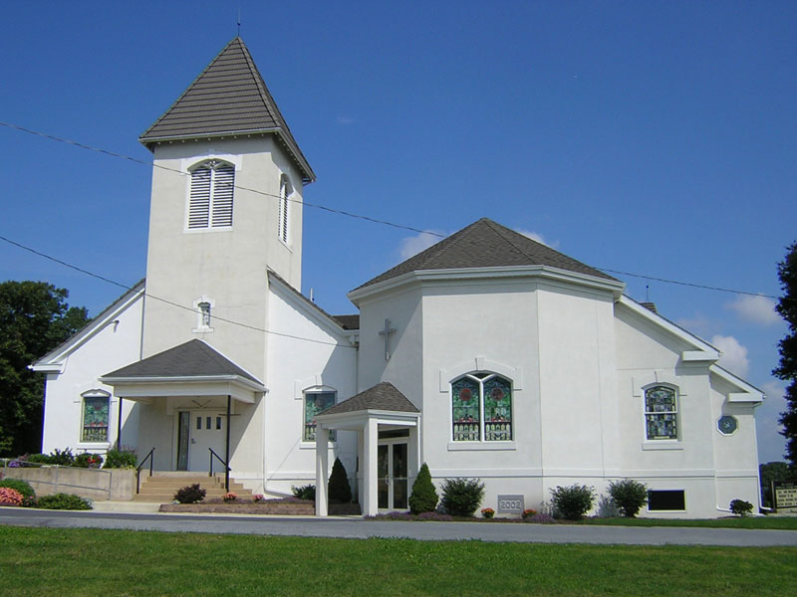
Still On the Journey
175 Years...This Far By Faith

ONE HUNDRED SEVENTY-FIFTH ANNIVERSARY

1840 – 2015

Sunday, April 19, 2015
FOREWORD AND DEDICATION

What is a church? It is not a building of wood and stone with stained-glass windows. The building is only the setting for what takes place inside.

The Church is people—people who pray together, who sing together, who work together, who laugh together in the service of God and others. For 175 years people have given life to the original building and to the one which stands here today and they will continue to do so. Some are long gone and others are still unborn, therefore;

To all the saints—past, present, and future, who labor, have labored and will labor in the Lord’s vineyard at New Jerusalem Evangelical Lutheran Church, this anniversary bulletin is dedicated with love and gratitude for their labors.

The 2015 New Jerusalem Council members are:

Ty Rissmiller, President
Kenneth Keck, Vice President
Dawn Wengert, Secretary
Betty Eshbach
Ted Eshbach
Sheila Gehman
Joshua Keck
Linda Moyer
Susan Schlenker
Cheryl Wiltrout

NEW JERUSALEM LUTHERAN CHURCH HISTORY

New Jerusalem Evangelical Lutheran Church is located 3 miles south of Lyons. It is the daughter congregation of Christ (Mertz) Church of Dryville. Tradition says the village of New Jerusalem was named after the church and not the church after the village. Evidence shows the village was named before the congregation was organized. In 1840 a difference of opinion arose at Christ Dryville over the services of the Rev. John Knoske, who was elderly and loved by the older people. Those loyal to Rev. Knoske withdrew from Christ Dryville and formed the congregation at New Jerusalem. The younger element who desired a younger pastor remained at Christ Dryville.

The cornerstone of the first church was laid April 20, 1840, on half an acre of ground donated by Andrew Schiffert. Later two more acres were obtained from the Herbein farm and set apart for a cemetery. The first constitution was drawn up by Rev. Daniel Kohler and started out as a purely Lutheran constitution. However, in the preamble, provision is made for a union church. The constitution was adopted on the day of the cornerstone laying. The building operation made rapid progress and on October 3 and 4, 1840, the church was dedicated. The cost of the first church was $2,156.53. By December 26, 1840 the debt was reduced to $877.39. On that day twelve men were elected to the Church Council. During the year 1840 Pastor Knoske gave his salary of $60.53 to the building fund.

The Reformed congregation was organized in 1841, one year after dedication. A pipe organ was procured in 1858. The church was renovated in 1870 at a cost of $233.50.

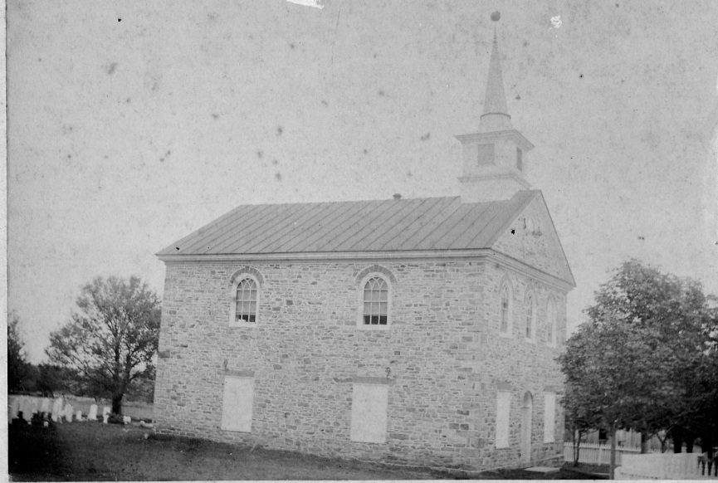
New Jerusalem Union Church, 1840

THE NEW CHURCH

By 1916 it was felt that the old church was no longer adequate to meet the needs of the growing congregation and active Sunday School. Opinion was divided as to whether to remodel and enlarge the old building, or build a new church. Another consideration was whether each congregation should build for themselves or join hands and erect a union church. The congregation decided upon the latter and out of that decision came ten articles of agreement which were signed by the officers of the two congregations on May 20, 1916.

The articles provided that a new Lutheran Church should be built, with the Reformed congregation having the privilege of worshipping on alternate Sundays. It was agreed that the Sunday
School remain a Union Sunday School. It was also agreed that both congregations should contribute to the new church, but that
an account would be kept of the contributions and, if at a later
date the Reformed desired to build for themselves, their contributions would be refunded without interest. With the signing of these articles, the old church was torn down and good material used in the erection of the new church.

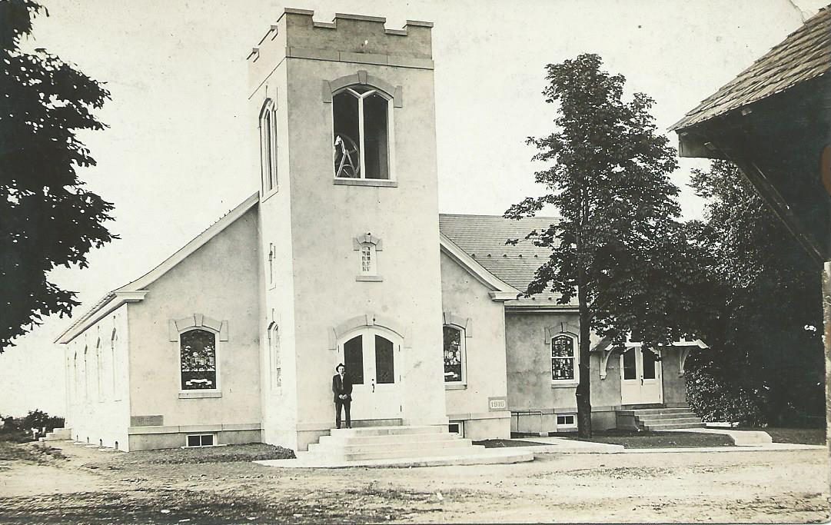
The cornerstone was laid August 6, 1916. The new church was built of native Rockland stone, stuccoed, heated with steam and lit by electricity. A cemented basement is under the main building, used by Sunday School classes and for other activities. The Sunday School Annex rests on the spot where the old church stood and when opened with the main auditorium the total seating capacity was about 700. Labor and materials to the amount of $5,000 were donated. The church was dedicated on August 9, 1917 practically free from debt and was then valued at $15,000.
New Jerusalem Church, 1916

While the church was in the process of erection the two congregations worshipped in a local hall, but solemnized Holy Communion in Christ Church, Dryville. The dear mother (Christ Dryville) from whom we hailed, lovingly remembered her daughter. This daughter (New Jerusalem) gave two sons to the ministry: the late Rev. A.E. Youse, Myerstown, PA and the late Rev. David H. Frederich, Bethlehem, PA.

IMPROVEMENTS TO THE CHURCH

Several improvements were made to the church. The bell tower was rebuilt in 1927 with waterproof bricks. A new Moeller Pipe Organ was installed on September 6, 1936, at $1,950 plus $250 for the chime which was donated by Mr. & Mrs. John G. Keller, as a memorial, in honor of their departed parents. October 31, 1936 there was an enlargement of the cemetery.

In 1940 the interior of the church was painted and carpet installed.

In 1953 the Longswamp-New Jerusalem-Huffs-Bowers Parish was dissolved. Longswamp joined with Mertztown to form a new parish and the three remaining congregations formed a parish that lasted until 1967. At this time, church was held every other Sunday in New Jerusalem because the Pastor had three congregations.

In 1956 the exterior of the building was painted and new lights installed in the social room.

In 1957 a well was drilled on the west side of the building.

In 1960 new lights with new wiring to meet state code regulations were installed, the entire inside redecorated, and the floors refinished.

In 1966 major improvements were done, with the extension of the church structure on both sides of the bell tower, excavation under the Sunday School room and lavatory facilities and an inside staircase on the east side. Three double door exits were made to the basement, and the entire ceiling of the basement
was plastered. A new fireproof furnace room was added. The heating system was changed to oil fired hot water boiler, with three area controls, baseboard radiation and copper tubing.
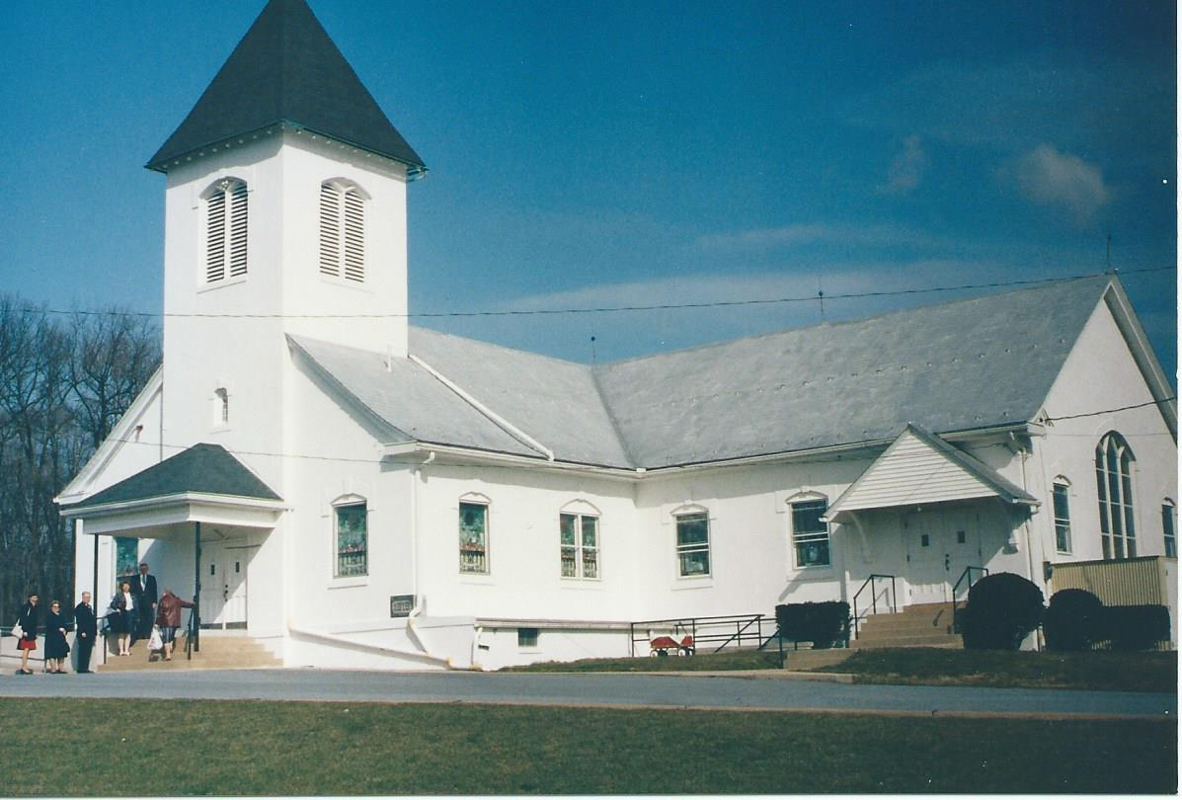
The cornerstone was reset on March 12, 1967. The 1840 cornerstone was reset without disturbing any contents and a sealed plastic container with membership lists and constitutions of both congregations were added.
New Jerusalem Lutheran Church, 1988

The carpeting in the church was replaced in 1968 with the cost being borne by the Sunshine Society.

The Bowers-Huffs-New Jerusalem Parish was dissolved in 1967 following a fire which destroyed the Bowers church in late 1966. The Huffs-New Jerusalem Parish was formed in its place. The parsonage in Topton was purchased by the newly formed parish. The mortgage was paid off in 1971.

In 1972 the storm windows were installed.

In 1973 the driveway to the church was widened and repaved and the parking lot paved.

Pastor Charles T. Herman who started at New Jerusalem Lutheran Church in 1953, retired in 1975 and the congregation was without a pastor until 1976 when Pastor Henry Fromhartz accepted the call to the parish. With his coming, the parsonage was renovated and modernized. A fire in the parsonage in 1977 caused quite a bit of damage to the basement and smoke damage throughout the house necessitating further renovation of the parsonage.

In 1978 the exterior of the church was sandblasted and painted. In that year Pastor Fromhartz transferred his ministry to Ashland, PA and the congregation was again without a pastor. Rev. Donald Wert accepted the call to our parish in l979.

In 1980 the roof of the bell tower was replaced. The interior of the church was painted and insulation was installed in the celling of the main sanctuary and the Sunday School annex.

In 1982 a roof was placed over the main entrance to the church.

In 1988 all the woodwork on the outside of the building was covered with soffit, and new aluminum gutters installed.

In 1988-89 a ramp was built for easier access of the handicapped to the church.

In 1989 the large stained glass window in the Sunday School room was re-leaded.

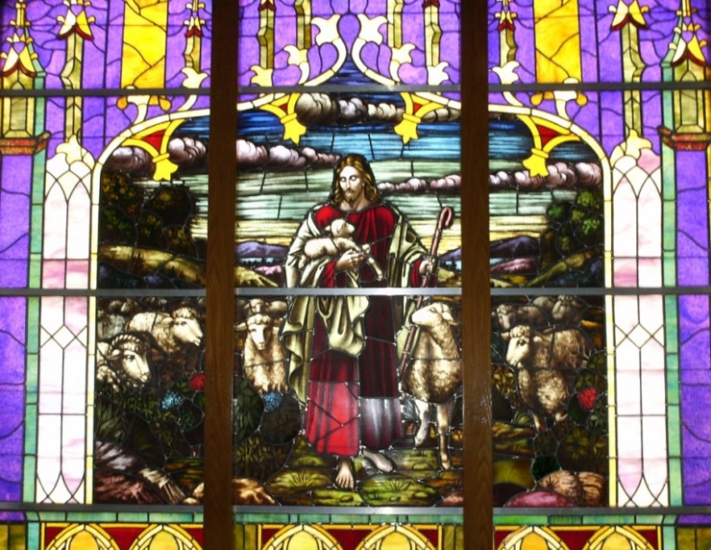
In 1989-90 the remainder of the stained-glass windows in the building were re-leaded.
Stained Glass located in the old Sunday School room

DISSOLUTION OF THE UNION CHURCH
AND BUILDING OF THE ADDITION

In February of 1997 the UCC congregation requested the dissolution of the Union Church and on November 2, 1997 a Service of Dissolution was held. At this time the Leaping to Life campaign was launched. This campaign was set in motion with the goal being to raise at least $100,000 by May of 2000 to pay
the Lutheran’s share of the equity figure to the UCC congregation. The highlight of 2000 occurred on May 7th with a debt-free celebration. This celebration marked the completion of the equity payment of $100,000 to the New Jerusalem United Church of Christ.

The Sunday School Grove was sold in 1998 netting $72,730 to be split between the Lutheran and UCC congregations. The money was put into the Leaping to Life campaign. In 1998 the United Church of Christ was built and the Lutheran congregation became the sole occupants of the New Jerusalem Church.

In March of 2000, the Council voted to have the church participate in the National 2000 Accessible Campaign and an Accessibility Committee was formed. The two back pews were shortened so that those in wheelchairs could sit and worship with family members and a sound system was purchased to aid those with hearing disabilities. The committee engaged the services of a local architect, John Watkins. The plan was presented to the congregation on April 29th and a vote was held on May 6th. The accessibility project passed with an 80% approval vote.

In May 2002, the contractor (DESCCO Design & Construction, Inc.) began to build the new addition. The project
added a new narthex, office space for the pastor and the church
secretary, and created additional Sunday School classrooms. But most importantly, the project made all areas of the building easily accessible with the addition of the elevator. On December 1, 2002, a special dedication service was held to dedicate the new renovation. The new cornerstone was filled with items from the original cornerstone and new items from the congregation.
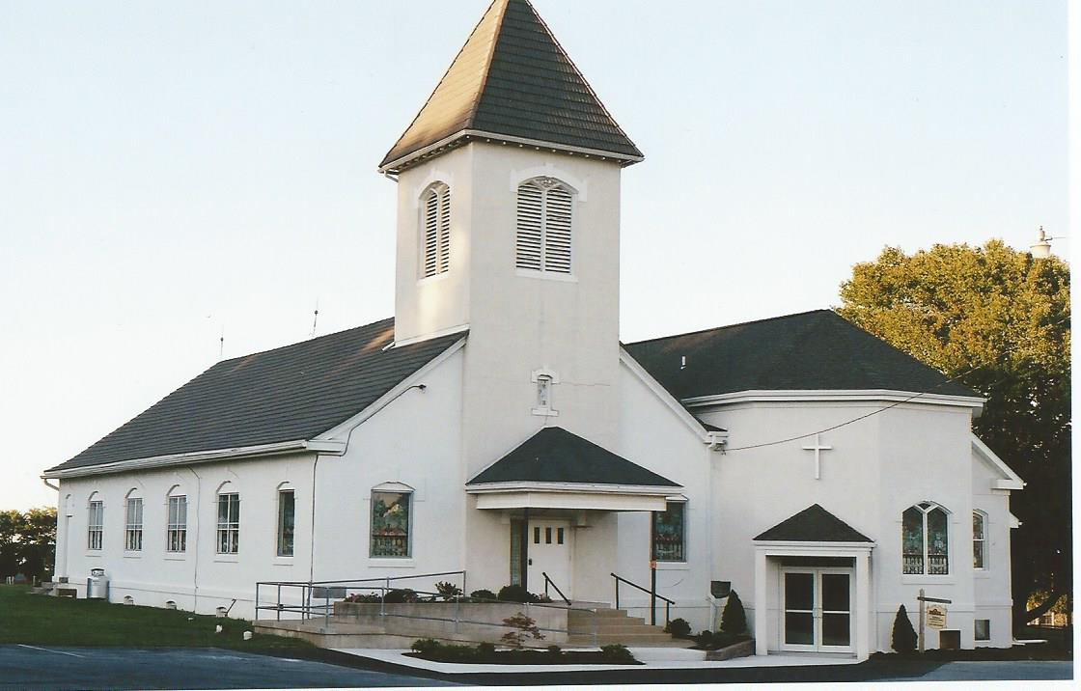
New Jerusalem Evangelical Lutheran Church, 2002

A push button automatic door opener with a motion detector under the door jamb was installed in 2007 on the narthex doors. This door opener was a Memorial Gift by Bill and Nancy Hess in memory of Bill’s mother and father, Verna and Howard Hess.

In 2012 and 2013 the church received bequests from the David Moyer estate and Pearl Sharadin estate. At the time the total was $159,000. It was brought to the attention of the Council that upgrades were needed for safety and code regulations in the basement. A $30,000 expenditure was approved to make necessary changes in the kitchen. Two restaurant ranges, a three compartment sink, and a new refrigerator were some of the items purchased.

PASTORS WHO SERVED AT
NEW JERUSALEM LUTHERAN CHURCH

Rev. John Knoske 1840-1846
Rev. C. A. Griebler mentioned in 1841-1842
Rev. Daniel Kohler 1847-1850
Rev. John Grimm mentioned in 1851
Rev. G. A. Hinterleitner, DD 1852-1866
Rev. Alfred D. Croll 1867-1869
Rev. Simon R. Boyer 1869-1871
Rev. David K. Humbert 1872-1903
Rev. Henry W. Warmkessel
Asst. to Rev. Humbert for several years
Rev. John W. Early (supply) 1903-1904
Rev. William F. Bond 1904-1944
Dr. C. E. Keiser (supply) 1944-1945
Rev. Wilson Hartzell 1945-1953
Rev. Charles T. Herman 1953-1975
Rev. Henry G. Fromhartz 1976-1978
Rev. Donald W. Wertz 1979-1986
Rev. Jennifer Mehl Ferrara 1987-1990
Rev. John Aurand (interim)
Rev. Laura L. Stoneback 1991-2003
Rev. David J. Wartluft (interim) Served until 6/5/04
Rev. Michael L. Reist 2004-2007
Rev. Marilyn E. Hasemann 2008-2014
(Pastor Hasemann was installed on February 2009
as a fulltime pastor after serving as an interim pastor)
Ruth Doty, M. Div., M.S. 2014–Present
Pastoral Care Provider

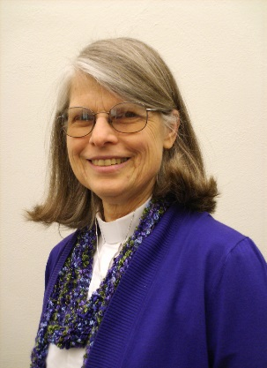
Since July, 2014 pastoral care for the congregation is being provided by Ruth Doty, an approved candidate for ordained ministry in the ELCA. A graduate of Christ College (Valparaiso University), Purdue University, and the Lutheran Theological Seminary at Philadelphia, she also trained at the University of Pennsylvania and is a licensed marriage and family therapist.

Born and raised in New York City, Pastor Ruth spent childhood summers in rural upstate New York. She and her husband, Richard (Rick), have lived in Alabama for 11 years and Wescosville since 1984. They are blessed with two sons and daughters-in-law and three grandsons.

Pastor Ruth has been employed in a variety of ministry settings: therapist at a community mental health center and at the Church Renewal Center at Good Shepherd Rehabilitation Hospital, Associate Director of Family and Counseling Services, Coordinator for Disaster Preparedness and Recovery in northeastern Pennsylvania through Lutheran Congregational Services, and pastoral care provider at St. Paul’s, Cementon, and St. John’s, Jim Thorpe East. She helped to establish an adult literacy program (Northwest Alabama Reading Aides) and Safeplace, a shelter for victims of domestic violence. She helped lead the first years of Project Help, teens from Holy Spirit, Emmaus, PA who repair houses in rural Maine, and has coordinated numerous Camp Noah teams. (Camp Noah is a program of Lutheran Social Services Minnesota designed to help children impacted by disaster.) International travel includes visits to our synods sister synod in Saxony, Germany and a visit to ELCA missionaries in Arusha,Tanzania.

Pastor Ruth feels privileged to serve with the members of New Jerusalem at this time and thinks that the theme for our anniversary, “This far by faith, still on the journey” also describes her life.
ORGANISTS WHO SERVED
NEW JERUSALEM LUTHERAN CHURCH

John A. K. Youse (served 40 years)
Alan S. Angstadt
Verna Sheetz
Grant Goeltz
Edwin Hoppes
Irene Oswald
Mildred Keiser
Annabelle Folk
Lillie Schlegel
Teresa Giovannelli
June Snyder
Shirley Weida
Nancy Hafer
Judy Noll ( 1995-2008)

After the resignation of Judy Noll, we were unable to find a permanent organist, therefore we had to rely on supply organists to fulfill the position. Some of the supply organists and piano players who served are Cheryl Felix, Rexine Krause, Jean Winkler, Helen Schellenberger, Sandra Wayman, Dorian Nygard, Sharlene Stauffer, Phyllis Fenstermacher and Faye E. Dey. Faye Dey, a lifelong member of New Jerusalem Lutheran Church, currently serves as Choir Director. Helen Schellenberger is serving as the Handbell Director.

With Our Sincerest Appreciation
≈ Thank You ≈

We humbly thank the New Jerusalem Evangelical Lutheran Church Family for allowing us to show our love by serving as the 175th Church Anniversary Committee. We were blessed with this privilege to do God’s will, to reflect our love for Him, and to reflect our love for each other.

A special thank you to Bishop Samuel Zeiser and The Rev. James Dunn, New Jerusalem UCC. We are honored that you were able to share in this special occasion with us.

We thank all of our brothers and sisters in Christ for your prayers and service. We receive them for the Praise and Glory of God.

May God continue to bestow blessings upon you!

The 175th Anniversary Committee

Erma Gajewski, Chairperson
Sara Jane Beshore
Pastor Ruth Doty
Linda Moyer
Cindy Rissmiller
Susan Schlenker
Dale Schwoyer
Dawn Wengert
Cheryl Wiltrout
Korinne Hotzman, church secretary

With thankfulness to
our faithful God and
for the hard work and
generosity of those who
have gone before us,
we celebrate that we have
come this far by faith,
and are excited to
still be on the journey.

